

Board of Directors Business Meeting Tuesday, February 24, 2026, 7:00 a.m.
Location: Idaho Falls Auditorium District Office/Zoom Videoconference
https://us06web.zoom.us/j/83920608308

1690 Event Center Drive, Idaho Falls, Idaho 83402

Room 2416

Participants: Rob Spear, Mike Carpenter, Ron Warnecke, Brian Ziel, Lisa Casper (via Zoom), Mark Fuller, Jennifer Bjornlie, Redge Sorenson, Nancy Rhode (via Zoom)

Agenda
- Action Item - Call to Order 7:00 AM
- Action Item – Accept Agenda – Spear explained that Agenda items VI and VII will be swapped. Warnecke moved to accept the agenda. Carpenter seconded. Motion passed.
- Action Item - Accept the Consent Agenda
  - Meeting Minutes 1-27-26
  - Review of Payables/Financials – Spear presented a payables list totaling $11,915.42. Spear also reviewed the financial statements for December. Tax revenues for December 2025 were $ 153,186.95 compared to $157,130.27 in December of 2024. Carpenter asked for clarification on prepaid expenses. Spear said that since IFAD paid all of the Liability and D&O expenses in a lump sum; The amount shown, $3,205.22 is what is left of the prepaid amount for the policy period March 1, 2024, through February 28, 2025. Carpenter also asked about the balance in the Mountain America Credit Union account. Spear said the balance is higher than board policy but some of those funds will need to be transferred to the Bank of Commerce account to cover the FF&E payments. Spear also detailed some large expenses for the period; Snake River Landing annual dues of $23,298.35 and the Monthly FF&E payment of $48,921.80. Warnecke moved to accept the consent agenda. Ziel seconded. Motion passed.
- Discussion Item –Public Comment (Any member of the public is welcome to take three minutes and share concerns or questions with the Board). Carpenter recognized Ziel’s service to the Board and thanked him for his volunteerism. Ziel is moving out of the District in early March and must relinquish his board position. Ziel indicated he enjoyed being a part of the IFAD Board and appreciated the personal growth it has provided him.

- Discussion Item – Presentation from Redge Sorenson of Farm Bureau on building insurance and liability insurance. Sorenson provided the Board with a cost comparison of insurances. Sorenson did not have updated Management and Cyber insurance and used current policy premiums.
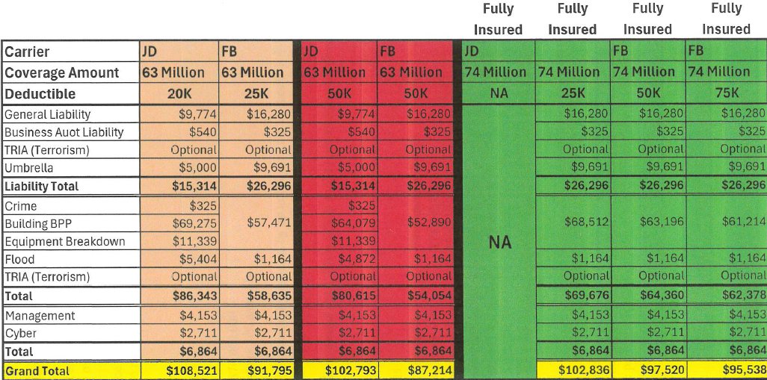

Carpenter asked about the coverage difference in Earthquake and Flood. Sorenson explained that Farm Bureau only offers $500K in earthquake and flood insurance. Sorenson said it would be unlikely that the entire building would suffer a total loss.

Sorenson said each year Farm Bureau increases building value by 6% but it is up to the policy holder if they want to increase the building value each year. Spear asked why equipment breakdown coverage was not listed. Sorenson said it is covered under the building value.

Warnecke asked if demolition costs were included in the coverage. Sorenson said those costs are covered.

Ziel asked if Cyber insurance would cover Centennial if a cyber breach occurred with Centennial’s system. Sorenson said it only covers IFAD.

Spear asked if Farm Bureau would be willing to just provide building insurance. Sorenson said Farm Bureau would but it would cost around $8K more.

Spear asked about the risk of premiums increasing on an annual basis. Sorenson said Farm
Bureau historically increases premiums 3% annually.

- Discussion Item – Presentation from Nancy Rhode of JD Fulwiler on 2026 Building, D&O Insurance, General Liability and Cyber Insurance costs. Rhode referred to a coverage comparison spreadsheet that compared current insurance coverages against proposals for increasing building insurance to $63M from the current $59M.
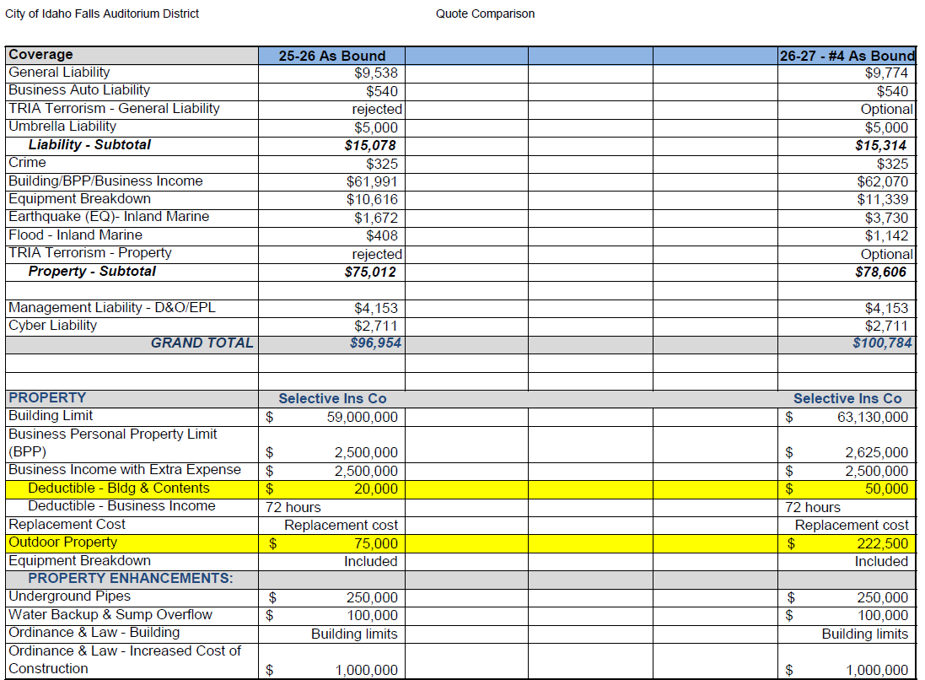

Rhode explained the parking lot lights are covered under Outdoor Property and the underwriter agreed to increase the limits from $75K to $222,500 (89 light poles at $2500 each) for no additional cost. Spear asked if those coverages cover windstorm, hail, vehicle damage, and vandalism. Rhode replied, it would cover the special form provisions of the property policy, the same as the building and contents. Everything is covered except what is excluded. Rhode said fire, hail, windstorm, theft, vandalism, smoke, aircraft are all covered. Ziel asked what is specifically not covered. Rhode said earthquake and flood, some water damage, and maintenance issues would not be covered.

Rhode said the proposals include moving the building value from $59M to $63M. This is a 6% increase that could be available every year. The insurer may need to ask for an adjustment annually. Most carriers are doing automatic increases every year. Rhode said at $59M the replacement cost is at $460 per square foot, and at $63M the replacement cost is $493 per square foot.

Casper wanted to know what the loss of business for 72 hours means. Rhode replied, this covers costs to continue operations and any extra expense. The deductible is by hours and not a dollar amount so this coverage would kick in if the facility were offline for more than 72 hours.

Spear asked if demolition costs are covered. Rhode said that is covered in two places under ordinance of law (code compliance issues) and building insurance.

Rhode explained the increase in earthquake and flood. Last year the rating software incorrectly calculated earthquake and flood insurance. Moving forward there is a two year increase in costs. It is doubling this year and then again next year.

Rhode explained the District has $5M is liability coverage.

Spear explained that another insurer is offering building coverage up to $74M. Rhode said coverage up to this amount seems excessive because in the event there was a claim it would not be a total loss claim. Rhode suggested to look at the competitor’s A.M. Best rating before making a decision.

Spear asked if the building insurance could be separated. Rhode said it could but she would not be the agent. Rhode asked about the cost difference. Spear said the cost at a $63M building value is $17,000 less. Rhode said the advantage of Selective is they cover an entire claim and there is no reinsurance. In comparison, Farm Bureau is purchasing reinsurance for anything over $3M. However, reinsurance is not a problem of the insurer. Warnecke said in his personal experience, reinsurance takes forever to resolve a claim.

Rhode asked about coverages for liability, cyber and Director and Operator insurance. Spear said the proposal by Farm Bureau used current quotes from JD Fulwiler. Rhode said that means Farm Bureau did not solicit any companies for those insurances and pointed out the Great Divide only works with appointed companies, and Rhode said it was unlikely that the policy could be transferred to Farm Bureau. Rhode said as the agent who bought liability, cyber and Director and Operator insurance to the table she said Farm Bureau needs to provide its own quotes for those lines of coverage.

Carpenter said the renewal is on March 1, 2026, and if we have until them to decide. Rhode cautioned that the policy needs to be renewed by 2-27-26 since March 1, 2026, is on a Sunday.

Carpenter said he looked up Farm Bureau A.M. Best rating and it was an A- with a negative outlook. This is compared to Selective, Great Divide, Amtrust and Indian Harbour who are all A+/XV rated. That means their company size ratings are $2B or more.

Spear stated that Farm Bureau has not provided the necessary information to switch insurances and the process seemed rushed despite Farm Bureau having three months to provide a proposal. Carpenter agreed that the Board was not provided ample information to switch companies and suggested staying with JD Fulwiler for 2026.

- Action Item – Approve IFAD Building, D&O Insurance, General Liability and Cyber Insurance policies for 2026. Warnecke moved to keep all insurances under JD Fulwiler and increase the building value to $63M and increasing the deductible to $50K. Ziel seconded. Motion passed.

Report and Updates
- Discussion Item – Presentation from Jennfier Bjornlie
  - Mountain America Center operations, January financial statement overview, and summary of operations. Bjornlie asked if there were any question on the revised December financial statements since she moved a large expense into the prior year. The Board had no questions.

Bjornlie then reviewed January financials that showed a net income of $6,083.54. Bjornlie said the month ended ahead of budgeted net income and cited 12 home hockey games, two ticketed events and less full-time labor costs. The reduced labor costs are the result of two vacant positions: the General Manager and Director of Marketing. Spear asked about the $6400 difference in sponsorship revenue. Bjornlie said Ticketmaster revenue came in less than expected for the year. That number was not known when the budget was set. Bjornlie said the -5,414.36 in building rent is the result of the rental costs for two ticketed events and Blue Cross of Idaho space rentals not covering actual costs. Bjornlie said other revenues (Food & Beverage, ticketing royalty, suites/loges, parking, and facility fees) help offset that negative amount and make events profitable. Ziel asked what is in miscellaneous revenue. Bjornlie said that is interest on sweep account.

Spear asked about the CIP expense and Bjornlie said that includes all CIP for the year and is expensed monthly. Bjornie said that amount includes new ice decking that will be ordered after the hockey season. Bjornlie said the CIP does not include the replacements of the heat sensors in the soft water tanks. Hopefully, that will be covered under warranty.

Carpenter asked about the reverse osmosis (RO) system. Spear explained the current plan is to place the infrastructure in the tool room. This would require moving or enlarging a door. Spear said the RO system would bring more clarity to the ice and it would extend the useful life of the Zambonis. Spear indicated none of the cold water supply to the building is currently receiving soft water treatment and pointed out the installation of the RO system will only benefit the ice and Zambonis. Bjornlie added that the RO will allow the ice temperature to be increased by 3-4 degrees which should lower utility bills. The RO system won’t be installed until after hockey season.

Bjornlie reviewed the balance sheet and Spear pointed out the retained earnings amount of $689,331.83 should not be transferred into the LGIP until later in the year when current operational revenues increase.

Bjornie said the new General Manager will be arriving on March 3, 2026. Carpenter commended Bjornlie for performance as the interim GM for the past three months.

- Discussion Item - Executive Director Report
  - Executive Director Report Summary – None provided
  - Building Update – Spear briefed the board on HVAC performance and the pending control work.
  - Cash Flow Update – Spear provided a cash flow update through 2033. Spear said projections for 2026 include the new control work. Revenues are projected to slightly exceed expenses until 2031 when donation revenue declines by $125K. However, in 2032 FF&E payments will be completed and net income will increase to $154K and $460K in 2033.
  - State Tax Commission Reports – Spear presented tax revenues for December 2025 totaling $153,186.95 compared to $157,130.27 in December of 2024.
  - Action Items
    - Spear to notify insurance companies of Board insurance selection for 2026.

- Discussion Item - Legal Report. No report was presented.

- Action Item - Adjournment to Executive Session – At 9:05 AM Carpenter moved that the Board move into Executive Session pursuant to Idaho Code 74-206 (1) (f). A roll call vote was conducted with Carpenter, Warnecke, Ziel and Casper voting in the affirmative.

- Executive Session - Idaho Code Section 74-206 (1) (f) To communicate with legal counsel for the public agency to discuss the legal ramifications of and legal options for pending litigation, or controversies not yet being litigated but imminently likely to be litigated.

2) Adjournment from Executive Session – Warnecke moved to adjourn from Executive Session at 9:17 AM. Carpenter seconded. Motion passed.

- Action Item –Action taken on Section 74-206 (1) (f) matter discussed in Executive Session. Warnecke moved to authorize Fuller to finalize and then send a letter to Acuity Brands Lighting, Inc. Ziel seconded. Motion passed.

Calendar and Announcements
A. Upcoming IFAD Meeting – Next Meeting on March 31, 2026
B. Discussion Item - Announcements and Minor Questions
C. Discussion Item - Agenda Items for March 31, 2026 – none discussed

F. Action Item - Adjournment from Public Session. Meeting adjourned at 9:18 AM

