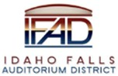

Board of Directors Business Meeting Tuesday, September 23, 2025,

7:00 a.m.
Location: Idaho Falls Auditorium District Office/Zoom Videoconference
https://us06web.zoom.us/j/81556273373

1690 Event Center Drive, Idaho Falls, Idaho 83402 Room 2416
Participants: Rob Spear, Terri Gazdik, Mike Carpenter, Ron Warnecke, Brian Ziel, Erik Hudson, Jennifer Bjornlie, Mark Fuller

Agenda
- Action Item - Call to Order 7:01 AM
- Action Item – Accept Agenda - Spear suggested moving presentation from Erik Hudson as part of Agenda Item VIII. Warnecke moved to accept the agenda with that modification. Carpenter seconded. Motion passed.
- Action Item - Accept the Consent Agenda
  - Meeting Minutes 7-29-25
  - Review of Payables/Financials – Spear presented a payables list totaling $79,152.81 with the majority of expenses being for the retro commissioning ($40,449.60) and $19,000 for the final installment for the Rudd & Co annual audit. Spear also presented the June and July financial statements with both months showing TRT revenues higher than 2024. For the year TRT revenues are 13% ahead of 2024 and 11% ahead of budget. Spear said that net income of $1,043,322.01 from 2024 operations was correctly recorded as retained earnings in the July 2025 financials. Carpenter moved to accept the consent agenda. Warnecke seconded. Motion passed.
- Discussion Item –Public Comment (Any member of the public is welcome to take three minutes and share concerns or questions with the Board). There were no public comments.
- Action Item – Per Sec. 5.1(b) of Annual Appropriation (Construction) Lease, renew the Appropriation Lease for an additional Renewal Term. Spear presented both the Notice of Intent to Renew and Notice of Renewal required by the Trustee, Zions Bank. Warnecke asked why this had to be done annually. Fuller responded that it is required by statute and that a current board can’t obligate future boards. Warnecke moved to approve both Notice of Intent to Renew and Notice of Renewal for Zions Bank. Ziel seconded. Motion passed.
- Action Item – Per Sec. 2.2 (b) of Annual Appropriation (FF&E) Lease, renew the Appropriation Lease for an additional Renewal Term. Spear presented both the Notice of Intent and Notice of Renewal for 2026 as required by Hogan and Associates Construction, Inc. for the FF&E financing. Carpenter moved to approve both Notice of Intent and Notice of Renewal for 2026. Warnecke seconded. Motion passed.
- Discussion Item – Review and discuss IFAD 2026 operating budget. Spear presented a draft copy of the 2026 IFAD budget. The major assumptions used were:
- Hotel Revenue – 2025 TRT plus 2% increase – Spear again said IFAD is trending toward a 13% increase over 2024 and 11% increase over budget. Some discussion took place on whether 2% was the correct number.
- Donation Revenue of $460,000. This is declining because most suite and loge box holders have paid their building obligations.
- Insurance – No increase budgeted
- Accounting Expenses go away due to the Executive Director assuming all accounting duties.
- YTT joint funded position budgeted at $30K.
- No consultant expenses budgeted.
- Gazdik requested that both meals/entertainment and travel budgets be increased to $2500. This is because the Executive Director role is changing to adopt a more statewide presence to engage other auditorium districts, state tax commission, Idaho High School Activities Association, and other sports related groups. Gazdik said it is important to build statewide knowledge about what IFAD is doing for eastern Idaho. Fuller commented that contractually, IFAD is supposed to have a suite to entertain. Spear said the board has elected to sell its suite but emphasized that Hudson is very good at providing suite and loge access to shows and concerts. Hudson said if IFAD took a suite that would cost the center $25K-$35K in revenue on an annual basis.

Spear said he would have a 2026 budget ready for approval at the next IFAD board meeting. Discussion ensued about the new hotels coming on board and the impact it will have on hotel revenues. It was decided to invite James West of InnTrusted hotel group to brief the board on the future of the hotel industry in eastern Idaho.

- Discussion Item – Discuss Centennial Management 2026 operating budget, capital improvement plan, and 2026 rate card. Hudson first presented information on Mountain America Center operations, July & August financial statement overview and year end projections. Here is a summary.
- July ended the month with a $82,729 loss. Hudson explained July was projected to be a losing month because it was a low event month but the amount was exacerbated by the poor performing Lyle Lovett concert on July 3. Market Days helped offset the loss from being worse. Gazdik asked why reimbursed expenses showed a negative amount on the revenue side. Hudson explained that Market Days was all done in-house and did not generate any reimbursable expenses normally recorded on the revenue side. This is unlike a touring show where reimbursed expenses earned from the show are positive revenue amount.
- Hudson said in anticipation of a loss, overall expenses were controlled and were $29,706 less than budgeted.
- August net income was a positive $103,638.
- Utility costs continue to decrease and Hudson attributes that to the system functioning more efficiently. Hudson said savings could approach $100K annually. Spear updated the board that all control work should be completed within the next two weeks. Spear said there have been some hiccups but ATS is now on track and will provide the center with a graphics package that will enable the ops team to better monitor HVAC performance.
Hudson presented a look ahead to the end of the year and reviewed the event matrix and said all calendar dates are filled through November. Hudson projects to end the year with net income of $502K. Hudson said rising costs, budgeted capital improvement items, and basic repair and maintenance costs have impacted the bottom line. Other highlights:

- Revenues will be $450K higher than budget.
- Full-time staff costs $16K above budget
- Event Staff reimbursable and Event Staff Hockey exceeded budget by $167K. Hockey costs are up because of the increased games
- Snowplow expenses were $29K below budget
- Overall, expenditures are $71K above budget.
- Capital Improvement costs are $71K for the year.

Hudson presented the rate card for 2026. The rate card has not been adjusted since the opening of events center and Hudson is recommending a 3.5% increase. Hudson justified the increase because all other costs are increasing. Gazdik suggested an annual inflationary increase be considered. Carpenter agreed and asked if the market could bear an annual increase. Hudson said the customer will determine if rates become too high. Warnecke asked if existing contracts would fall under the old rate card. Hudson said they would along with multi-year contracts that have already been negotiated. Warneke also asked if Hudson discounts the rate for certain customers. Other than providing two complimentary events per year, Hudson said rental charges are never reduced. Hudson said they will work with customers on discounting ancillary rates and equipment rentals. Hudson will present a final rate card at the next IFAD board meeting.

Hudson then presented the 2026 operating budget. Here are the highlights:
- Net income conservatively estimated at $125K. Hudson presented the event matrix for 2026 and indicated all calendar dates are booked through May and he expects all the dates to be filled soon. Hudson presented a “working shows” spreadsheet that details all the concerts and shows under consideration. Overall, there are 34 concerts and shows under consideration. Hudson explained that, now in year four, they know what shows will be successful and are avoiding shows that have not done well. Outside of Disney on Ice, other family shows have not faired well.
- Hudson detailed all the revenue lines and indicated all suites and loges are sold for the upcoming year. Hudson explained that when suite and loge contracts come up for renewal, they will adjust the deadline for suite and loge box holders notify the event center of usage from one week to 30 days prior to the event. This will allow the box office more time to sell the suite to other groups.
- Advertising and sponsorship revenue will increase because of the success selling advertising on IPTV.
- Carpenter asked about bringing in an NHL game to the event center. Hudson said they continue to review the possibility but the cost is $350K plus other travel related costs. Ticket prices would be around $200 and that may be more than the market can bear. Carpenter asked how the ICCU arena in Boise can make it pencil out. Hudson said best case scenario is they break even.
- Warnecke asked why Ticketmaster/Marketing Revenue is down $110K. Hudson said the rebate bonus amount has been moved into the advertising and sponsorship line.
- For 2026 the event day totals are:
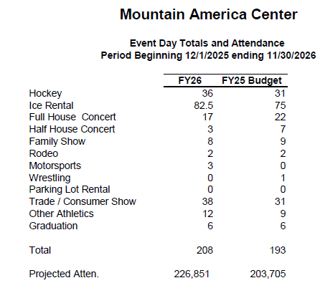

- Hudson said full-time staff salary costs will increase 4% and that benefits are budgeted at a 10% increase but those are currently being evaluated. Hudson indicated they will most likely enter into another arrangement for benefits.
- Maintenance costs will increase slightly with the following budgeted for 2026
  - Omni $307.00 - monitoring for cameras, doors, etc.
  - TK Elevator - $866.72 -Bills quarterly
  - Falls Pest - $280.00 -Bills quarterly
  - Western States- $475.00 This includes generator service + new
  - Revel $4,450.00 -IPTV Feb-Jan
  - Lewis Mechanical - $3,864.00 -Billed monthly- as needed service
  - ATS - $2,140.00 - HVAC Controls support
  - Power Engineering - $600.00 - bills monthly - water and Reverse Osmosis
  - Legacy Fire Inspection - $110.83 -Now completed in Nov
  - SIR - $942.00 - billed monthly - ice plant
  - Raymond - $126.00 - Loading dock plate service
  - Rigging Motors - $95.00 Billed annually.

Warnecke asked if the beer line system is on a maintenance contract. Hudson said they are cleaned once a month but that cost is absorbed by Diamond Concessions.

- For capital improvement items the parking lot will be restriped and new ice decking will be purchased.

Ziel asked how the IFAD Board can support Hudson’s team. Hudson responded that the center is in a good spot and the only thing is to try and find a way to acquire the necessary property to build an ice plex. Gazdik suggested finding ways to promote usage of vacant seats at hockey games and concerts. Hudson said they continue to evaluate and said they have rolled out a “tickets for veterans” for concerts. For hockey, a lot is dependent on what Kevin Greene wants to do for hockey. There is some discussion on raising the usage minimum for hockey season ticket holders from 70% to 80%.

Hudson said he is concluding his three year venue management certification process. The certification is the highest venue management certification available.

- Discussion Item – Discuss hiring a rebate analyst to calculate if any arbitrage is owed. Spear briefed the board on the various compliance items required by the trustee (Zions Bank). Included in the compliance items is the requirement to engage a rebate analyst to review if any rebate is owed to the federal government. Spear said he contacted Stephanie Bonney and she stated in an email, “Basically when we sell a tax exempt bond, the government is giving up taxes (basically giving a grant to local governments) so there are a number of rules that prohibit governments from basically using the fed money to make money (called arbitrage). If you don’t meet the exemption rules, then you have to pay a portion of that “grant” back. The exemption for your project was that the project was expected to take 3 years to build, and that can be extended to 5 years. So, the money you borrowed is required to be allocated (committed, not necessarily spent) within 5 years.” Spear asked Bonney, “Since the project was completed and money spent in that 3-year window, we don't need to do anything?” Bonney responded. “That is correct.”

Spear explained that Zions did not see it that way and referenced the following language in the Trust Indenture. “Section 4.5. Certain Gross Proceeds Exempt from the Rebate Requirement.

(a) General. A portion of the Gross Proceeds of the Certificates may be exempt from rebate pursuant to one or more of the following exceptions. The exceptions typically will not apply with respect to all Gross Proceeds of the Certificates and will not otherwise affect the application of the Investment limitations described in Section 4.3 hereof. Unless specifically noted, the obligation to compute, and if
necessary, to pay rebate as set forth in Section 4.6 hereof applies even if a portion of the gross proceeds of the Certificates is exempt from the rebate requirement. To the extent all or a portion of the Certificates is exempt from Rebate, the Rebate Analyst may account for such fact in connection with its preparation of a rebate report described in Section 4.6 hereof. The District may defer the final rebate Computation Date and the payment of rebate for the Certificates to the extent permitted by Regulations § 1.148-7(b)(1) and
§ l.148-3(e)(2) but only in accordance with specific written instructions provided by the Rebate Analyst.”

Spear said based on that response he asked Zions to provide contact information for rebate analysts. Spear said he received two recommendations and contacted both. Spear presented an engagement letter from Arbitrage Compliance Specialists who would perform the calculation for $3,250. Spear also received a quote from Brent Mason of Eide Bailey for $5,000. Spear said in conversation with both individuals, they did not expect IFAD to incur any rebate costs but that a study is needed to verify.

Spear explained that the stated yield in the Tax Compliance agreement is 5.25% and he did not think any of the interest earnings on any of the funds earned from investments of the Trustee was greater than the yield.

Spear also shared the spending exemption stated in the Tax Compliance Agreement listed below.

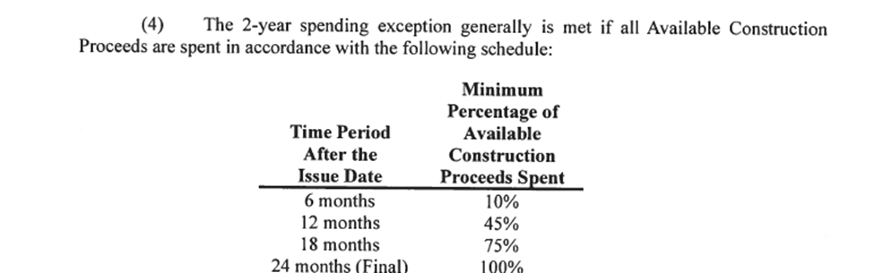

In conclusion, because of the high yield and because all construction funds were spent in 21 months, it is unlikely the transaction will have any arbitrage issues. It is possible there may be negative arbitrage because the construction funds were spent before the 24 month deadline.

Gazdik asked if there is negative arbitrage would IFAD receive a rebate. Spear said he did not know the answer but would follow up. Gazdik recommended that Spear contact Laura Lewis and brief her on the rebate compliance item and ask for her recommendations on who can perform this work, costs to perform work and what is negative arbitrage. Spear said he would report back at the next IFAD board meeting.

Report and Updates
- Discussion Item – Presentation from Erik Hudson
  - Mountain America Center operations, July & August financial statement overview and year end projections. This was covered under agenda item VIII.
  - Spud Kings Update – Hudson said the season has started and they are now down to a 24 person roster. The banners were unveiled at the first home game. Hudson expects the team to perform well this season.
- Discussion Item - Executive Director Report
  - Executive Director Report Summary – not presented
  - Building HVAC Update – This was covered under agenda item VIII.
  - Cash Flow Update – Spear provided a cash flow summary through 2032 and indicated the District is in solid financial shape and it has ample time to pursue refinancing.
  - State Tax Commission Reports – Spear presented comparisons of 2025 TRT revenues for June and July to 2024 June and July revenues. June 2025 TRT revenues were 382,974 compared to $362,549 in 2024. July 2025 TRT revenues were $406,383 compared to $398,919 in 2024.
  - Action Items
    - Contact Laura Lewis
    - Request an engagement letter form Eide Bailey
    - Contact James West about attending next Board meeting.

- Discussion Item - Legal Report– There was no legal report presented.

Calendar and Announcements
- Upcoming IFAD Meeting – Next Meeting on October 28, 2025 – Because Board Chair Gazdik has a conflict, the board elected to move the October meeting to October 14, 2025.
- Discussion Item - Announcements and Minor Questions
- Discussion Item - Agenda Items for October 14, 2025, meeting
  - Approve 2026 IFAD budget
  - Approve 2026 Centennial Management budget and rate card
  - Discuss Rebate Analysts
  - Hear from James West of InnTrusted

Meeting adjourned at 9:04 AM

