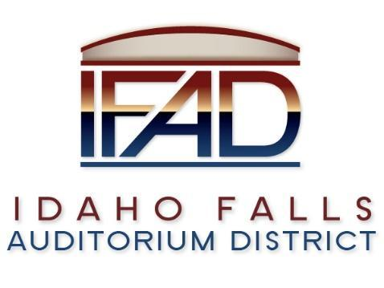

**Board of Directors Special Meeting**

**Tuesday, November 5, 2024, 7:00 a.m.**

**Location: Idaho Falls Auditorium District Office/Zoom Videoconference**

[**https://us06web.zoom.us/j/89067419910**](https://us06web.zoom.us/j/89067419910)

**1690 Event Center Drive, Idaho Falls, Idaho 83402 Room 2416**

**Participants: Rob Spear, Terri Gazdik, Mike Carpenter, Ron Warnecke, Lisa Casper, Mark Fuller, Erik Hudson, Bill Kissinger, Collin Mabe, Max Harrington**

**Agenda**

1. **Action Item -** Call to Order - Call to Order at 7:00 AM
2. **Action Item –** Accept Agenda – Spear suggested Hudson present September and October building financial information under III B. Spear also recommended canceling the 11-12-24 meeting since the board just met on 10-29-24 and again on 11-5-24. Regular board meetings would resume on 12-10-24. Warnecke moved to accept the agenda as amended. Carpenter seconded. Motion passed.
3. **Action Item** - Accept the Consent Agenda
   1. Meeting Minutes 10-29-24
   2. Review of Payables/Financials - Spear presented a payables list totaling $4,434.07 that was reviewed and approved. Hudson provided an overview of September financials and pointed out it was a different month because two ticketed events and one rental, originally scheduled in September, were moved into October. For September total revenues equaled $192K and expenses, before the management fee, totaled $201K. Once the management fee was added in, net income for September was a negative $21K.

Hudson presented some preliminary numbers for October and stated that it was a record month for the facility with revenues totaling $649K versus $243K in expenses before the management fee. The facility hosted events on 28 of the 31 days in October. Hudson estimated the net income for the month would be around $350K. For the year, net income is $1.1M. Hudson explained the numbers do not include ISHAA State volleyball tournament. Those numbers will be reflected in November. Hudson added that the ISHAA has extended its contract for five more years and will look at bringing other sporting events to the facility.

Casper moved to accept the consent agenda. Carpenter seconded. Motion passed.

1. **Discussion Item** - Public Comment – There were no public comments.
2. **Executive Session** - Idaho Code Section 74-206 (1) (f) To communicate with legal counsel for the public agency to discuss the legal ramifications of and legal options for pending litigation, or controversies not yet being litigated but imminently likely to be litigated. Gazdik moved to convene an executive session at 7:14 AM. Gazdik, Carpenter, Warnecke and Casper all voted in the affirmative to enter into executive session.
3. Adjournment from Executive Session 8:20 AM.
4. **Action Item** –Action taken on Section 74-206 (1) (f) matter discussed in Executive Session. Two action items were taken.
   1. Casper moved to send a licensing transfer letter to Delta controls. Warnecke seconded. Motion passed.
   2. Warnecke moved to accept a proposal not to exceed $175K from ATS to replace all the controls in RTUs 1-4. Casper seconded. Motion passed.
5. Calendar and Announcements
   1. **Upcoming IFAD Meeting** – Next Meeting on November 12, 2024. The Board elected to cancel the 11-12-24 meeting and convene at its next regular scheduled board meeting on December 10, 2024.
   2. **Discussion Item** - Announcements and Minor Questions
   3. **Discussion Item** - Agenda Items for December 10, 2024 – Discuss TRT revenues for September and possibly October.
6. **Action Item** - Adjournment from Public Session at 8:30 AM