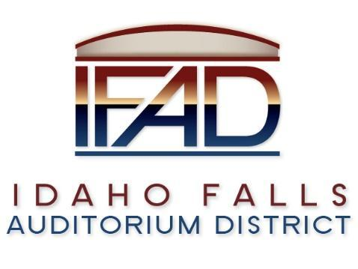

**Board of Directors Special Meeting**

**Tuesday, November 5, 2024, 7:00 a.m.**

**Location: Idaho Falls Auditorium District Office/Zoom Videoconference**

[**https://us06web.zoom.us/j/89067419910**](https://us06web.zoom.us/j/89067419910)

**1690 Event Center Drive, Idaho Falls, Idaho 83402 Room 2416**

**Agenda**

1. **Action Item -** Call to Order
2. **Action Item –** Accept Agenda
3. **Action Item** - Accept the Consent Agenda
   1. Meeting Minutes 10-29-24
   2. Review of Payables/Financials
4. **Discussion Item** - Public Comment
5. **Executive Session** - Idaho Code Section 74-206 (1) (f) To communicate with legal counsel for the public agency to discuss the legal ramifications of and legal options for pending litigation, or controversies not yet being litigated but imminently likely to be litigated.
6. Adjournment from Executive Session
7. Action Item –Action taken on Section 74-206 (1) (f) matter discussed in Executive Session.
8. Calendar and Announcements
   1. **Upcoming IFAD Meeting** – Next Meeting on November 12, 2024
   2. **Discussion Item** - Announcements and Minor Questions
   3. **Discussion Item** - Agenda Items for November 12, 2024
9. **Action Item** - Adjournment from Public Session

Posted on or before 7:00 a.m. on November 4, 2024