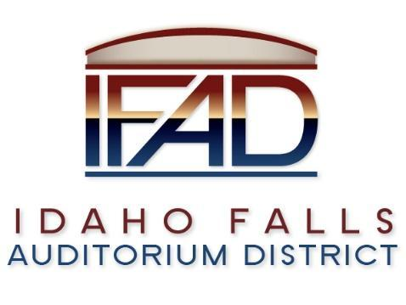

**Board of Directors Special Meeting**

**Tuesday, June 25, 2024, 7:00 a.m.**

[**https://us06web.zoom.us/j/83238017819**](https://us06web.zoom.us/j/83238017819)

**Location: Idaho Falls Auditorium District Office/Zoom Videoconference**

**1690 Event Center Drive, Idaho Falls, Idaho 83402 Room 2416**

**Participants: Rob Spear, Terri Gazdik, Mike Carpenter, Ron Warnecke, Brian Ziel (Zoom), Lisa Casper (Zoom), Mark Fuller, Erik Hudson**

**Agenda**

* 1. **Action Item** - Call to Order Meeting – Meeting called to order at 7:02 AM
  2. **Discussion Item** - Public Comment (Any member of the public is welcome to take three minutes and share concerns or questions with the Board). There were no public comments.
  3. **Action Item** - Adjournment to Executive Session. Gazdik moved that the IFAD Board convene into Executive Session. Gazdik, Carpenter, Warnecke, Ziel and Casper voted in the affirmative to convene into Executive Session.
  4. **Executive Session -** Idaho Code Section 74-206 (1) (f) To communicate with legal counsel for the public agency to discuss the legal ramifications of and legal options for pending litigation, or controversies not yet being litigated but imminently likely to be litigated.
  5. **Adjournment from Executive Session** Executive Session was adjourned at 7:46 AM.
  6. **Action Item –**Action taken on Section 74-206 (1) (f) matter discussed in Executive Session. Gazdik moved to authorize Gazdik, Spear and Hudson to negotiate a buyout with a naming right partner. Warnecke seconded. Motion passed
  7. **Action Item -** Adjournment from Public Session 7:50 AM.