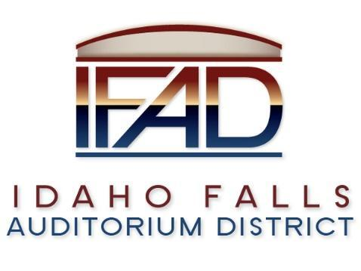
Board of Directors Special Meeting
Tuesday, June 25, 2024, 7:00 a.m.
https://us06web.zoom.us/j/83238017819
Location: Idaho Falls Auditorium District Office/Zoom Videoconference
1690 Event Center Drive, Idaho Falls, Idaho 83402 Room 2416

Agenda

  - Action Item - Call to Order
  - Discussion Item - Public Comment (Any member of the public is welcome to take three minutes and share concerns or questions with the Board).
  - Action Item - Adjournment to Executive Session

  - Executive Session - Idaho Code Section 74-206 (1) (f) To communicate with legal counsel for the public agency to discuss the legal ramifications of and legal options for pending litigation, or controversies not yet being litigated but imminently likely to be litigated.

  - Adjournment from Executive Session
  - Action Item –Action taken on Section 74-206 (1) (f) matter discussed in Executive Session.

  - Action Item - Adjournment from Public Session

Posted on or before 7:00 a.m. on June 24, 2024

